

**GradForce Web Recruitment Portal**

**A joint project of GradForce and Aspire2 International**

**01 October 2018**

**Installation and User Guide**

**Version 1.0**

Table of Contents

Introduction 3

System Requirements 3

Installation 3

Getting Started 5

Using The System 8

As Applicant 8

1. User Dashboard Page 8

As Employer 10

2. Employer Dashboard Page 10

3. Search Candidate Page 12

4. Search Result Page 13

5. Shortlist Page 14

6. Shortist Detail Page 15

7. Contact by Email Page 16

8. Applicant’s Appointment Page 17

9. Create Appointment Page 18

10. Skills Table Administration Page 18

As Administrator 19

11. Administrator Home Page 19

12. Companies Administration Page 20

13. Applicants Administration Page 21

14. Cities/Suburbs Administration Page 21

# Introduction

Web Recruitment Portal is a joint project by GradForce and Aspire2 International to develop a Minimum Viable Product (MVP) level recruitment system. The system is planned to be a web-based application that is intended for two types of users which are the **applicants** that will be looking for a job and the **employers** that will be searching for candidates for their job positions. Both types of users will be registering to the website and will be doing collaborations using the system. A third type of user which is the **Administrator** is available for system administrative functions.

This document provides information on how to install, run and use the GradForce Web Recruitment Portal. This version of the software is a prototype in which at this stage could run only locally on a single computer.

# System Requirements

1. GradForce Recruitment Portal software package
2. XAMPP Control Panel
3. Apache HTTP server, MySQL database and PHP running under XAMPP
4. Computer with Internet connection

# Installation

1. Download and extract all files from the OneDrive shared folder below.

Enter any user and password if asked.

<https://1drv.ms/u/s!AruK1Km5piCm4RWYfJ7hFslOUE7-?e=fuUsXT>

1. Install XAMPP Control Panel v3.2.2

* Run executable file xampp-win32-7.1.7-0-VC14-installer.exe

1. Copy/Extract source codes from the software package (ZIP file) into **RecruitmentPortal** folder.

Copy folder from the downloaded package named **RecruitmentPortal** to the **htdocs** folder of your XAMPP application (e.g. C:\xampp\htdocs\RecruitmentPortal).

1. Create MySQL database git702.
2. Run XAMPP Control Panel
3. Start Apache and MySQL then click MySQL Admin when both are running.

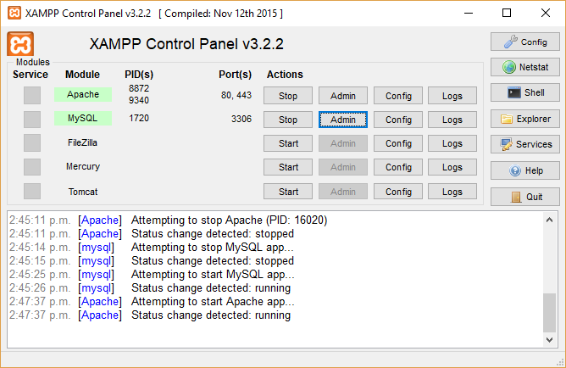

1. This will open below page on your browser.

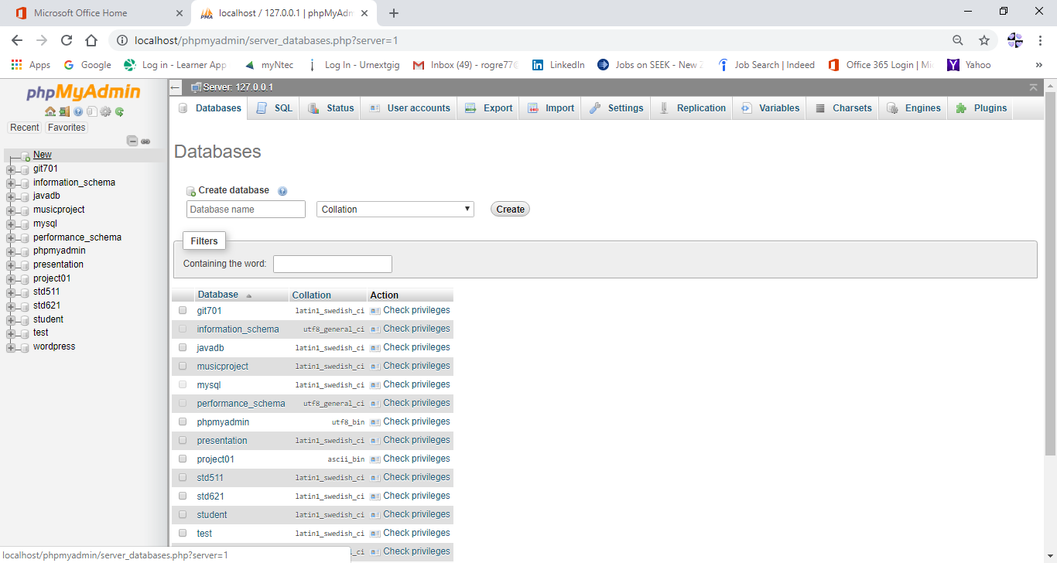

1. Click the New link to create a new database.
2. Enter git702 for the database name and click Create.
3. Click the newly created database on the left panel and click Import. Import the file named git702.sql from the downloaded software package.
4. Database git702 is now created.
5. One-time installation is completed.

# Getting Started

1. Run **XAMPP Control Panel.**
2. Start **Apache** and **MySQL.**

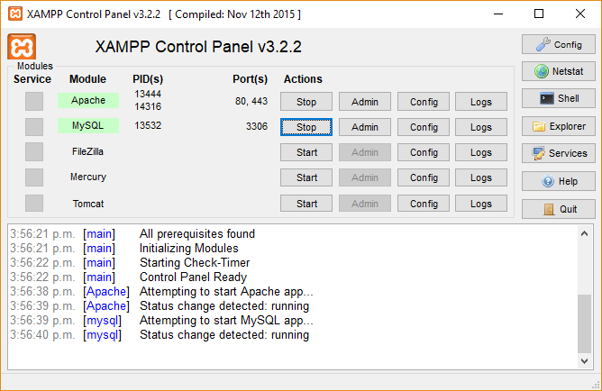

1. Open your Web Browser. Make sure you are connected to the internet. This is required to load the bootstrap libraries.
2. Enter or click URL <http://localhost/RecruitmentPortal/index.php> to open the local website. Shown below is the landing page which allows the user to login to the system if they have an existing account or to register either as an applicant or an employer. To register click on the Register link below and select whether you are registering as Applicant or Employer.

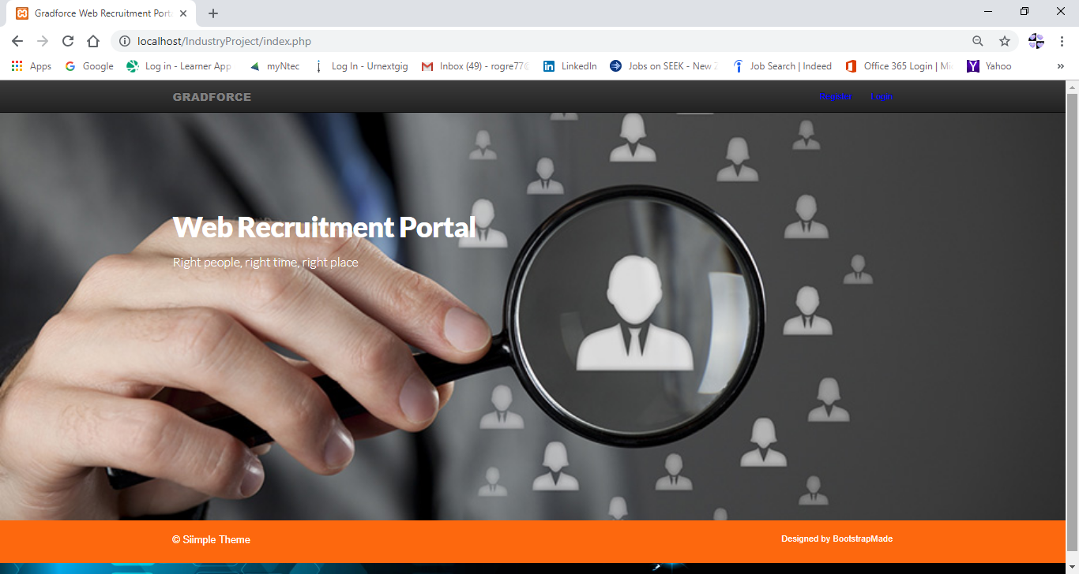

1. Logging in to the system.

Enter the registered account email and password to login.

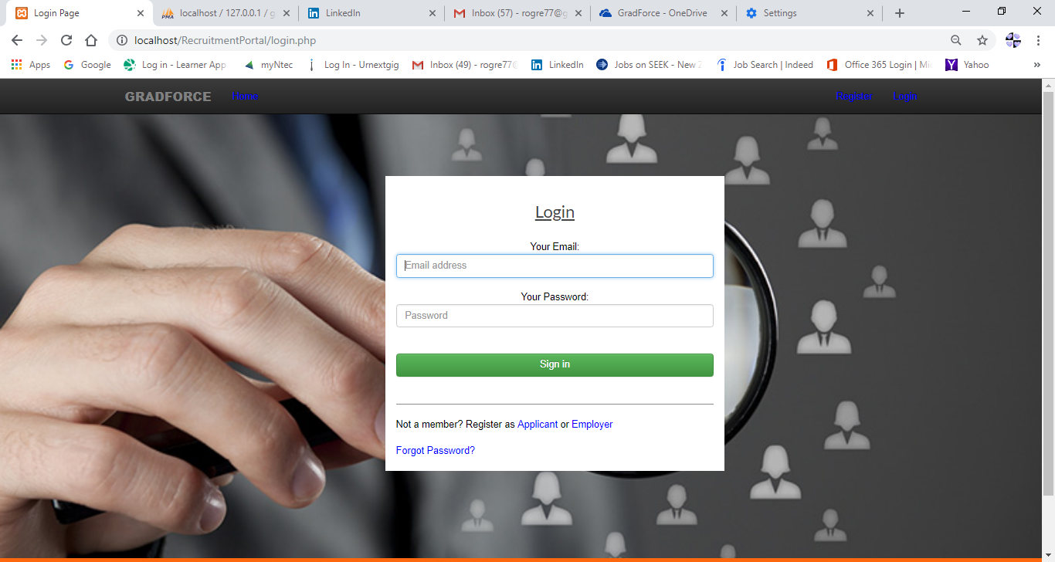

1. Resetting Password

In case the password has been forgotten, an option in the above login screen is available to reset it. This option will ask the user to enter the registered account email to be reset. After cicking the **Submit** button, an email will be sent to the provided mail containing a link for the password reset screen.

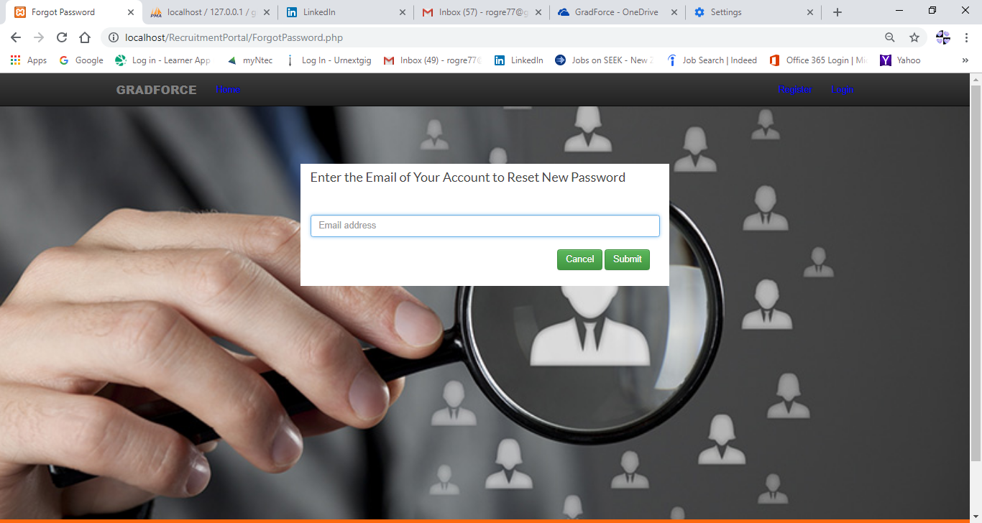

# Using The System

## As Applicant

After logging in with an applicant user account, you will be redirected to the User Dashboard which contains two tabs named My Profile and My Appointments.

### User Dashboard Page

Homepage for an applicant user.

Click on My Profile tab to view or update your user profile.

The user profile different sections like Personal Information, Educational Information, Visa Information, Other Information, Work Experience and Skills Set can be updated separately by clicking the update button  next to the section header.

After making the updates, the user can save the changes using  button or cancel using  button.

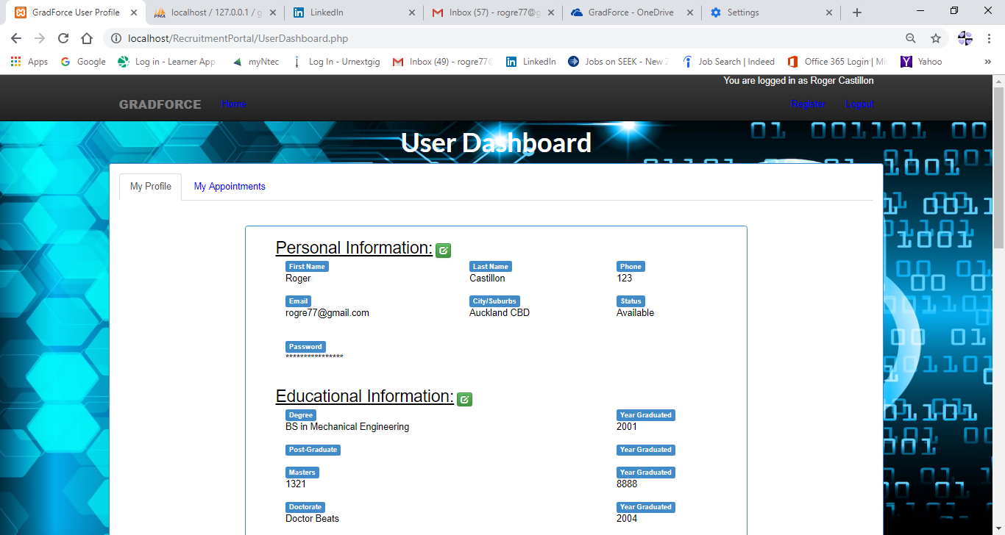

Click on My Appointments tab to view, accept or decline appointments.

The appointments tab will show all the user’s appointments in descending order showing the latest on top. Past appointments cannot be updated anymore and those that have passed and status=new or still pending (not accepted or declined) will be displayed in red color. The user is only allowed to view past appointments by clicking  button.

New appointments with future date can be accepted by user by clicking button or declined by clicking button. In case of user mistake, an undo  button is provided to revert the action but this is only allowed on the same day. On the next day you are not allowed anymore to undo your previous action.

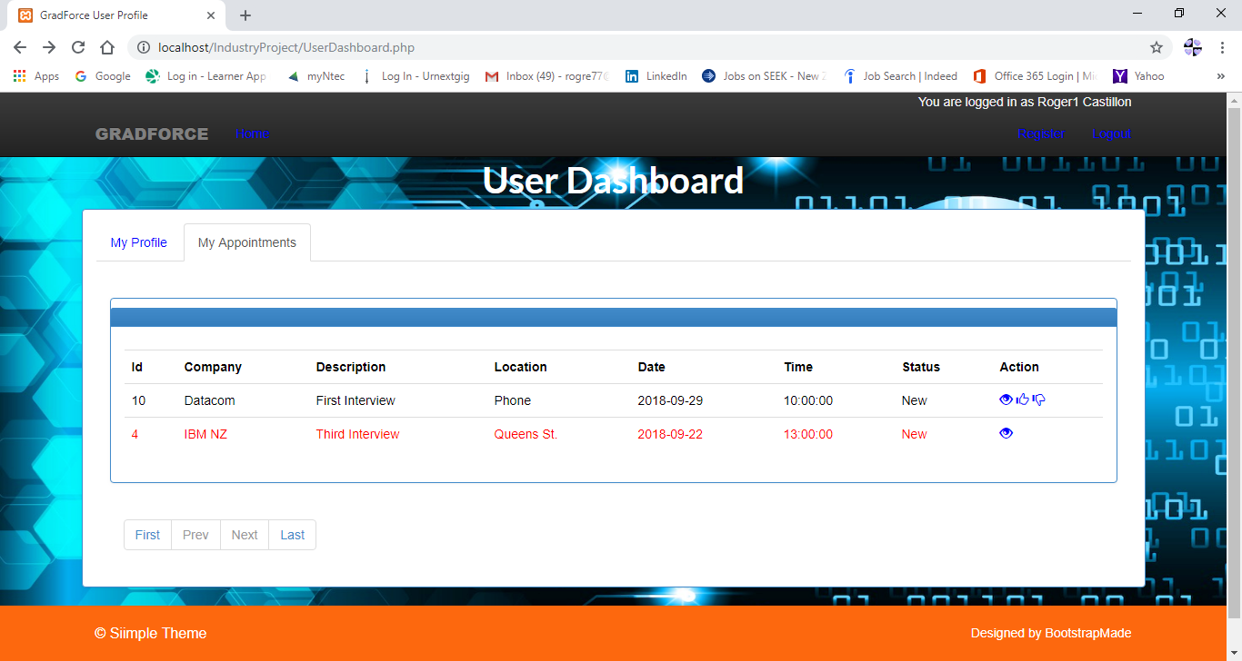

## As Employer

After logging in with an employer account, you will be redirected to the Employer Dashboard which has also two tabs named My Profile and My Appointments. But aside from these tabs, the employer user has also additional options which are the Home, Search Candidate, Shortlist and Skills links shown on the top menu.

### Employer Dashboard Page

Homepage for an employer user.

Click on My Profile tab to view or update the employer profile.

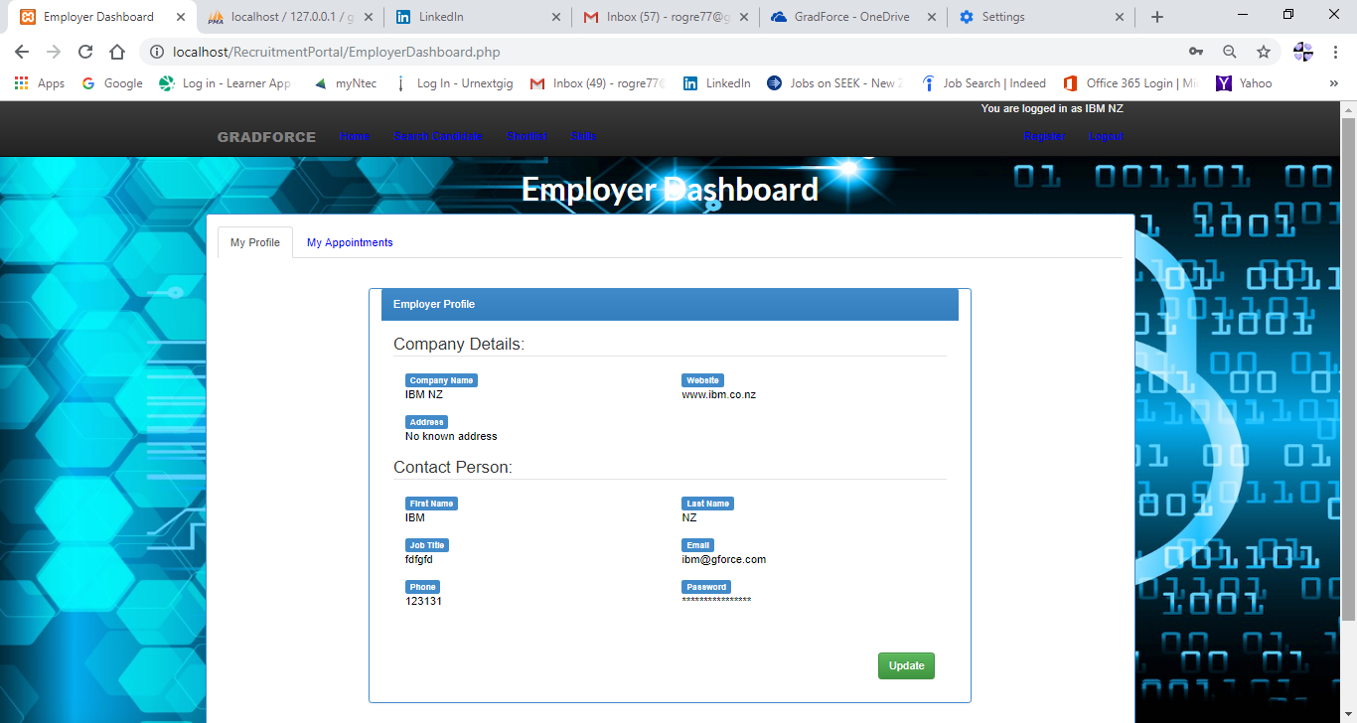

Click on My Appointments tab to view, update or delete appointments.

The appointments tab will show all the employer’s appointments in descending order showing the latest on top. Past appointments cannot be updated anymore and those that were not accepted or declined (status=new) will be displayed in red color. Only the appointments with status=New and with future date can be updated or deleted. In case of user mistake, an undo  button is provided to revert the update action but this is only allowed on the same day. On the next day you are not allowed anymore to undo your previous action. Delete action cannot be undone.

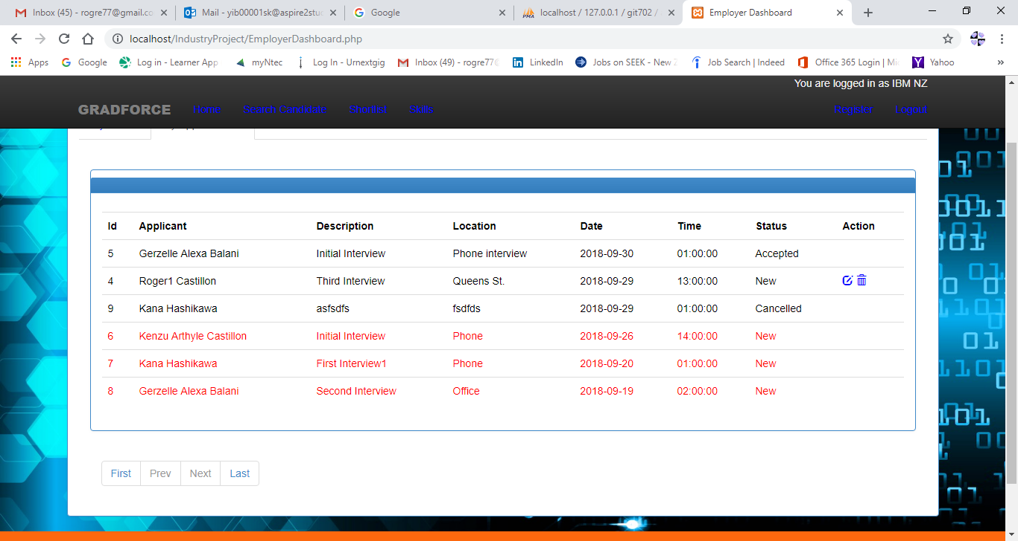

### Search Candidate Page

Click on the Search Candidate link on the top menu to use the candidate search facility.

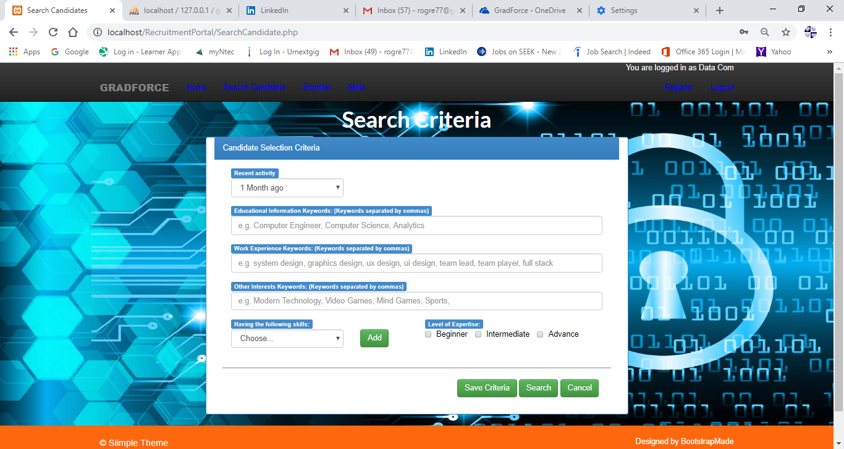

1. Recent activity - is used to include applicants who were active or who have logged in to the system for this period.
2. Educational Information, Work Experience and Other Interest keywords - these are the keywords searched on these specific sections of the applicant’s profile.
3. Skills and Levels of expertise – The skills with the matching level of expertise that are searched in the applicant’s skills set.
4. Save Criteria button – All entries and options on this screen is saved into the database for reuse later. This can be done for each company to have their own automatic search criteria.
5. Search button - this will bring you to the search result page.
6. Cancel button – this will bring you back to the employer dashboard.

### Search Result Page

This is the search result screen after clicking the search button. You can click on the different candidates on the left side of the screen and immediately you can get the related skills and qualifications information on the right side to help you quickly decide on which one to shortlist.

Click on Add to Shortlist button to remove the applicant on this screen and add to the company’s shortlist table.

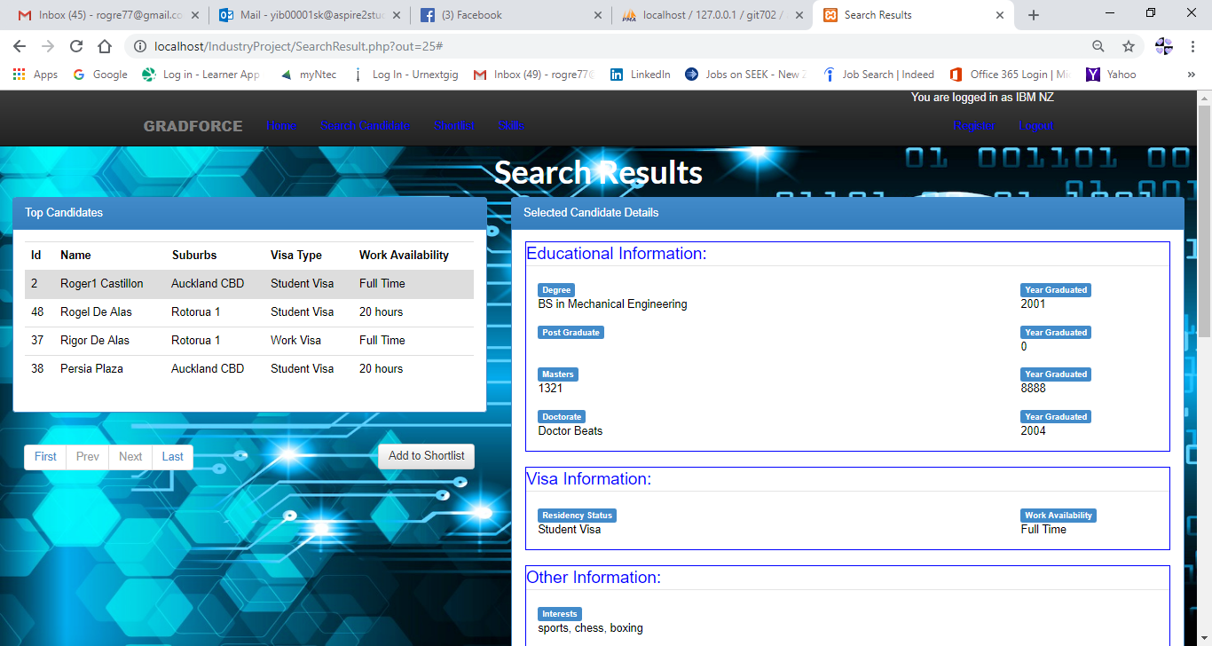

### Shortlist Page

This shows the shortlisted candidates of the company. There are two options allowed for each candidate, the edit button or delete button. The delete button  will delete the record from the shortlist table and the edit button  will bring you to the Shortlist Detail page. The screen will show more than one record for a candidate in case he/she has more than one pending appointment.

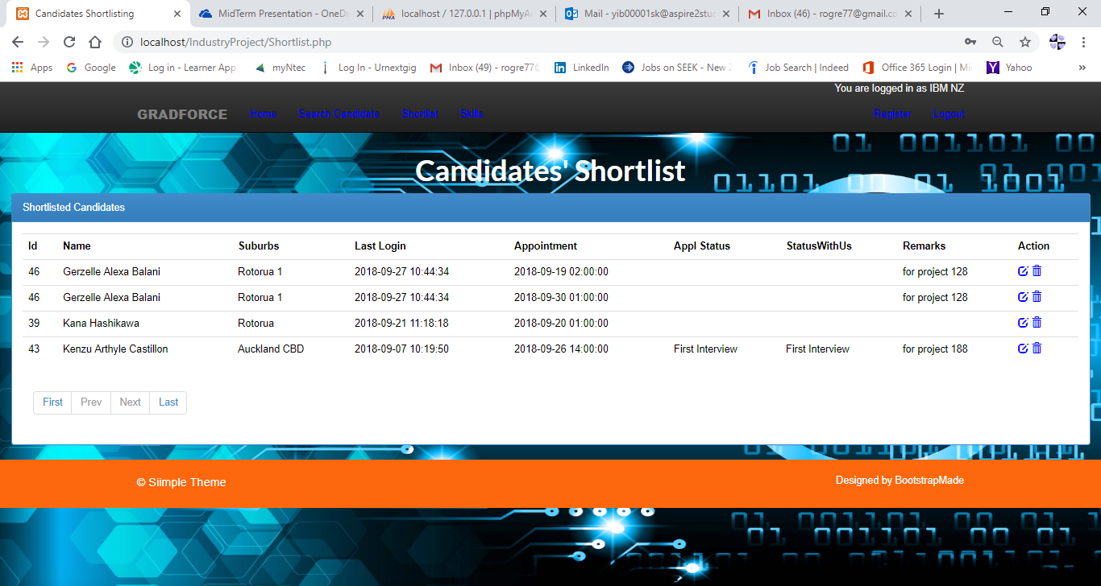

### Shortist Detail Page

This screen shows the candidate’s profile with additional fields **Remarks** for the employer to enter the purpose why he/she is shortlisted and a **StatusWithUs** field to show the candidate’s recruitment status in the company.

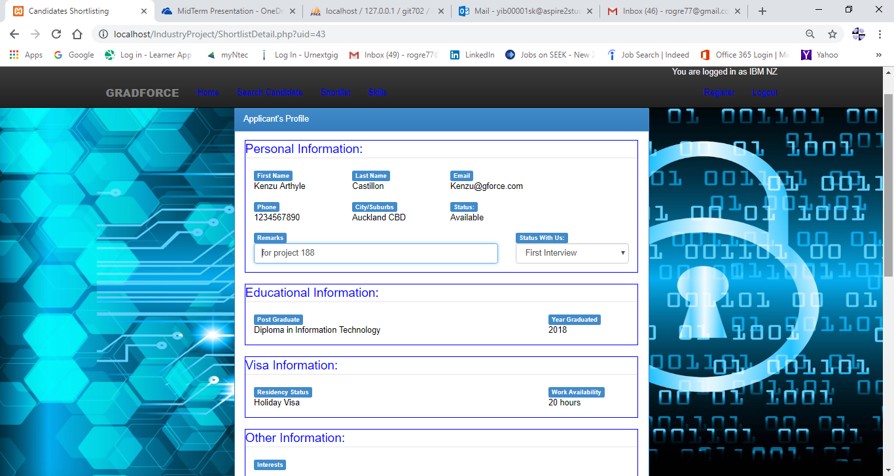

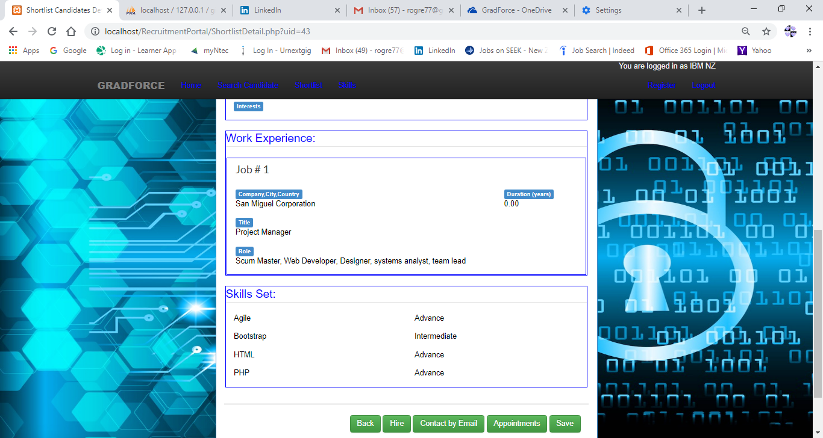

1. Save button – Saves the changes on **Remarks** and **StatusWithUs** fields.
2. Back button – Returns to the previous screen.
3. Hire button – Updates the status of the candidate as Hired so us his/her status in the system will not be to other companies.
4. Contact by Email – Opens the **Contact by Email page**.
5. Appointments – Opens the **Applicant’s Appointment page**.

### Contact by Email Page

This screen prepares an auto-generate email containing details of the selected candidate and the user’s company. The screen contains a CC field where the user can add email addresses that he wants to include in the mail. The Subject field is auto-generated and is editable.

The message field is also is auto-generated from a template and is editable as well and can be saved for the next use. It can contain the following variable parameters that will actually be translated to it’s actual value from the candidate and company details.

***%Applicant*** – Name of Candidate

***%CompanyName*** – Name of Company

***%CompanyEmail*** – Company Email address

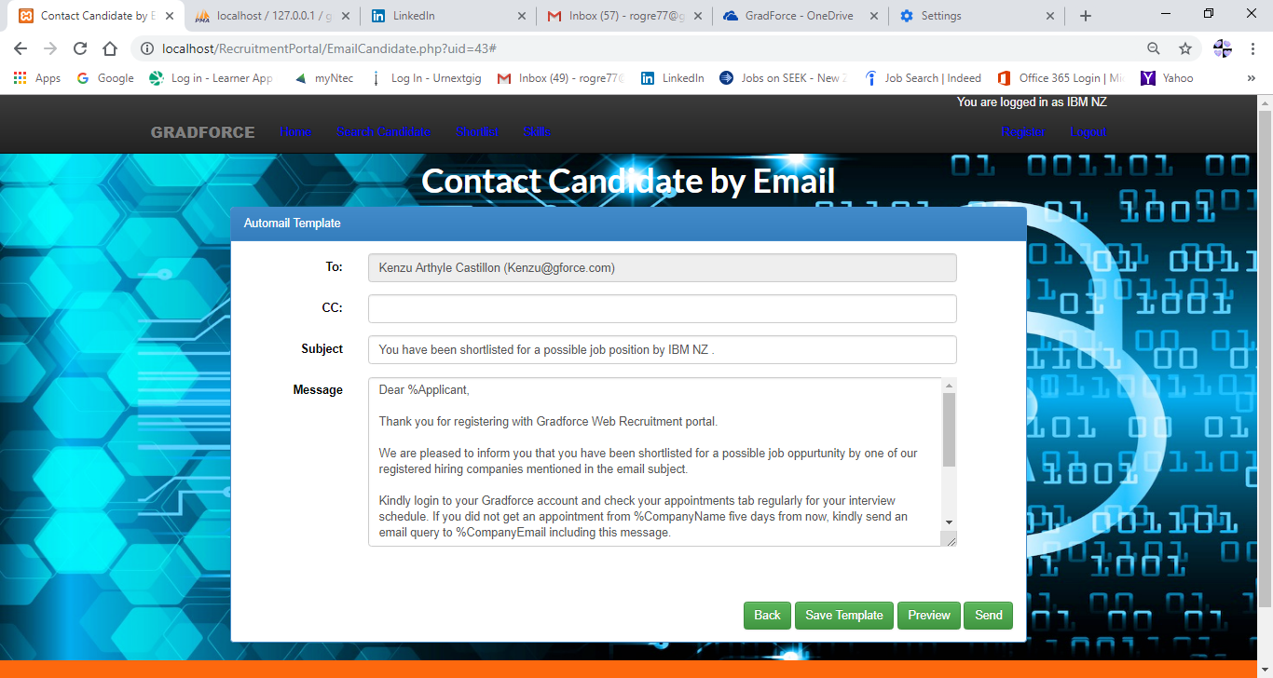

1. Back button – Returns to the previous screen
2. Save Template button – Save the current Message template for the next use.
3. Preview button – Previous the message before sending.
4. Send button – Sends the email.

### Applicant’s Appointment Page

This screen lists the existing appointments of the selected shortlist candidate if any. Again past appointments cannot be updated anymore and those that were not accepted or declined (status=new) will be displayed in red color. Only the appointments with status=New and with future date can be updated or deleted. In case of user mistake, an undo  button is provided to revert the update action but this is only allowed on the same day. On the next day you are not allowed anymore to undo your previous action. Delete action cannot be undone.

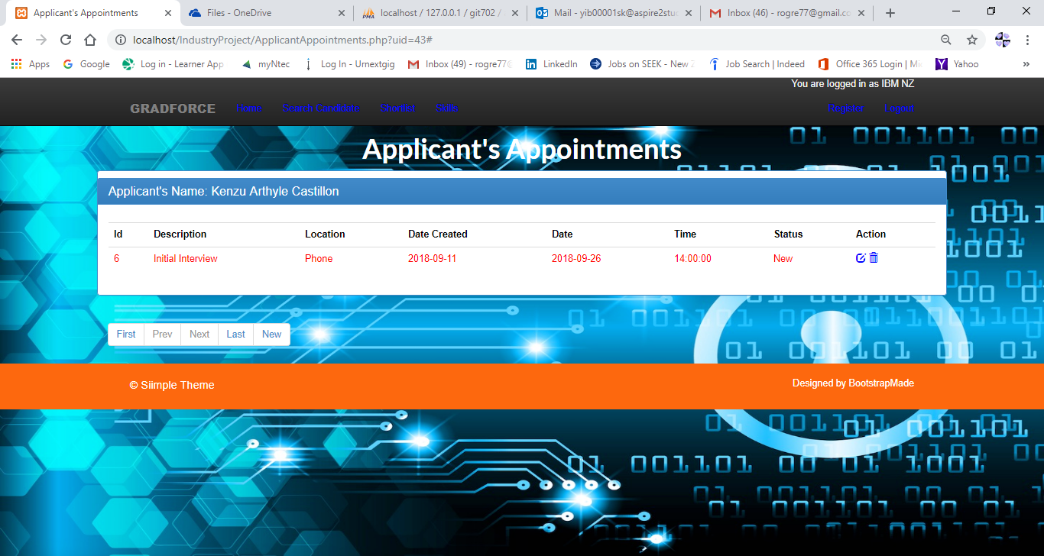

The delete button  will delete the appointment and the edit button  will bring you to the **Update appointment page** below. A browsing button is provided just below the appointment’s table to be used in scanning through pages in case of multi-page list. **New** button is provided here to create a new appointment with the selected candidate. This will open the **Create Appointment page**.

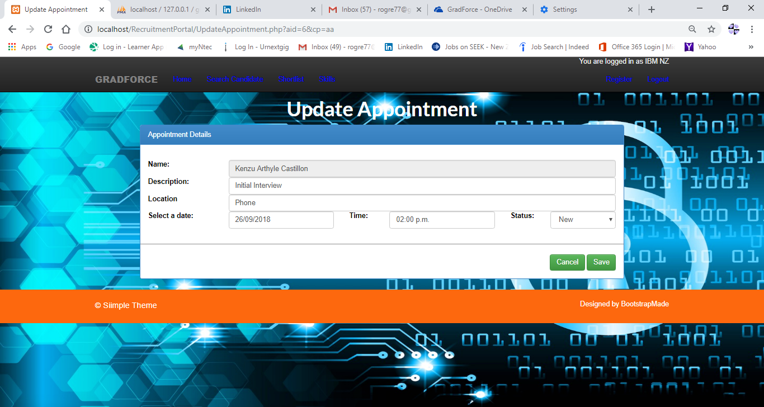

### Create Appointment Page

This screen will make a new appointment for the selected candidate. **Cancel** **button** ignore changes and return to previous screen. **Save button** saves the changes and return to the previous screen.

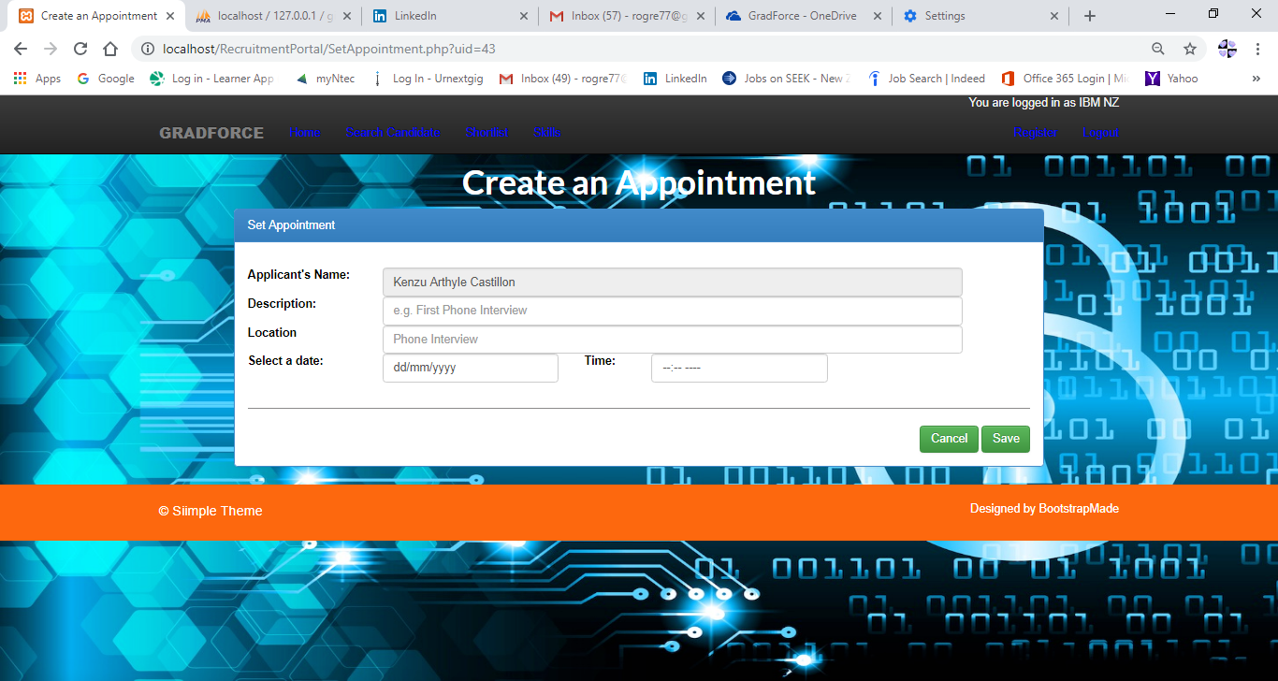

### Skills Table Administration Page

This screen is the common facility for all companies to add skill names to the Skills Lookup table used during the applicant’s registration. Each company can only modifiy or delete the skills which they have added originally.

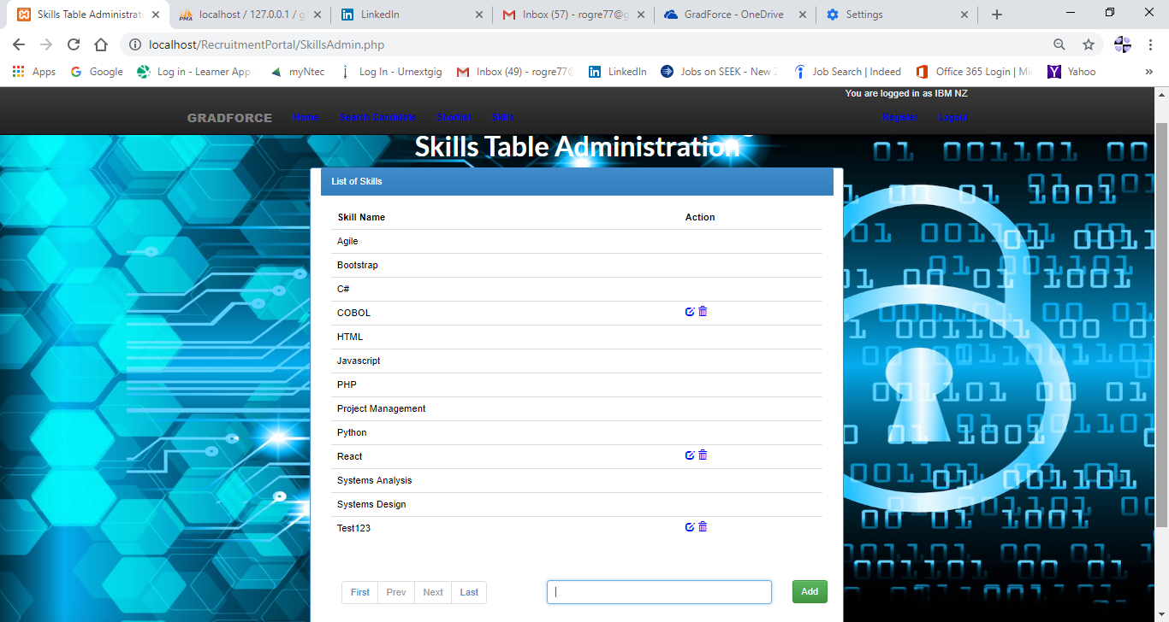

## As Administrator

After logging in with an administrator account, you will be redirected to the Administrator Home Page which has the following options which are the Home, Companies, Applicants and Suburbs links shown on the top menu. Homelink brings to the same screen. Companies link opens the **Company Administration page**. Applicants link opens the **Applicants Administration page**. Suburbs link opens the **Cities/Suburbs Administration page**.

### Administrator Home Page

Homepage for an Administrator user.

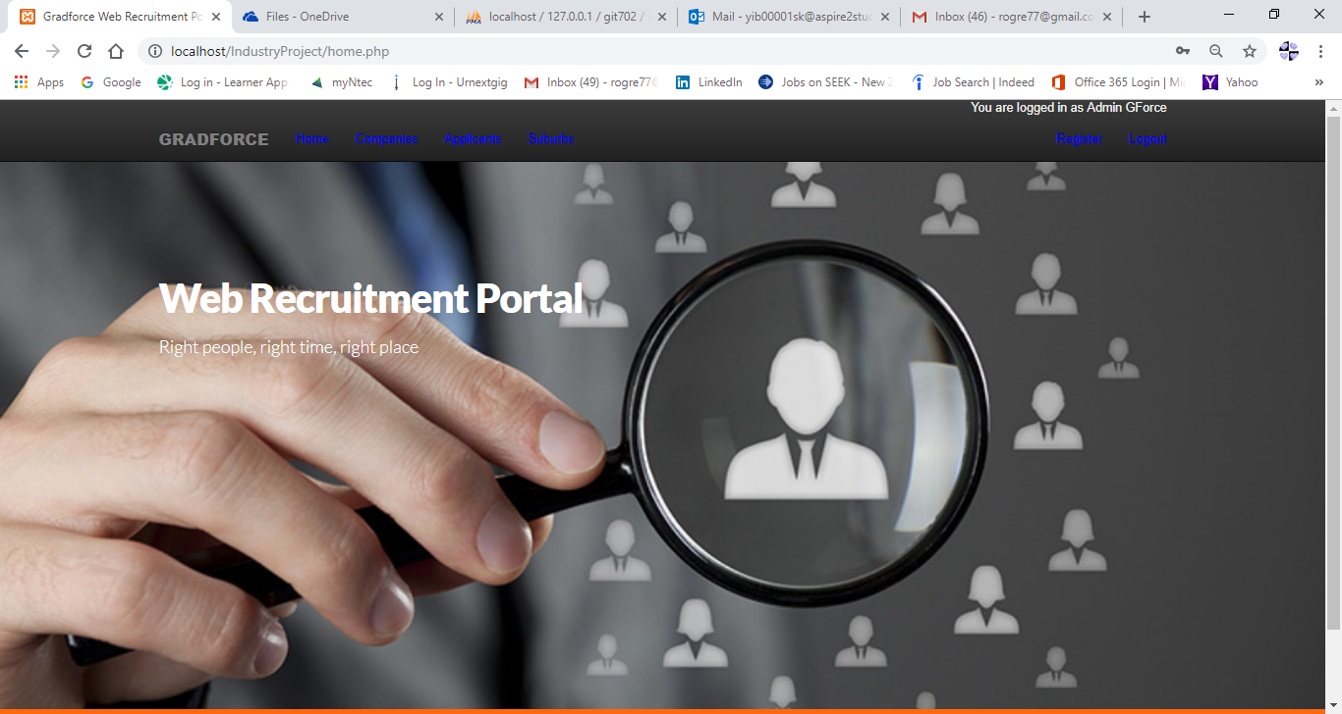

### Companies Administration Page

This screen is for the system administrator’s used only. The  buttons opens the **Update Company Status** page that allows to update the company user’s status to Enabled or Disabled and the  button deletes the company. This option should be taken carefully as this will totally delete the company from the system together with all it’s relates tables.

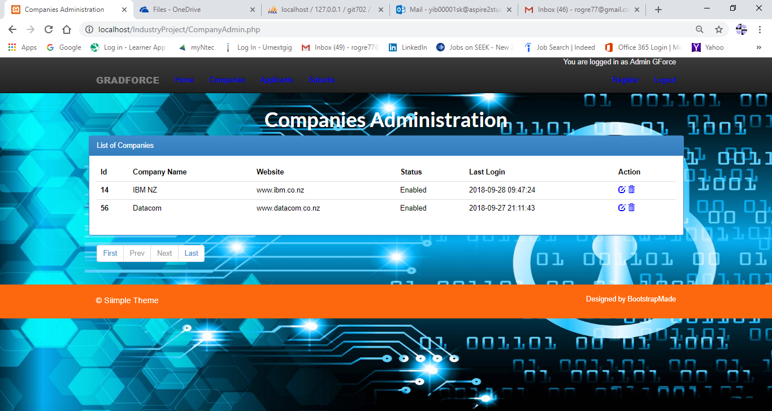

### Applicants Administration Page

This screen is for the system administrator’s used only. The  button opens the **Update User Status** page that allows to update the applicant user’s status to Enabled or Disabled and the  button deletes the applicant. This option should be taken carefully as this will totally delete the applicant from the system together with all it’s related tables.

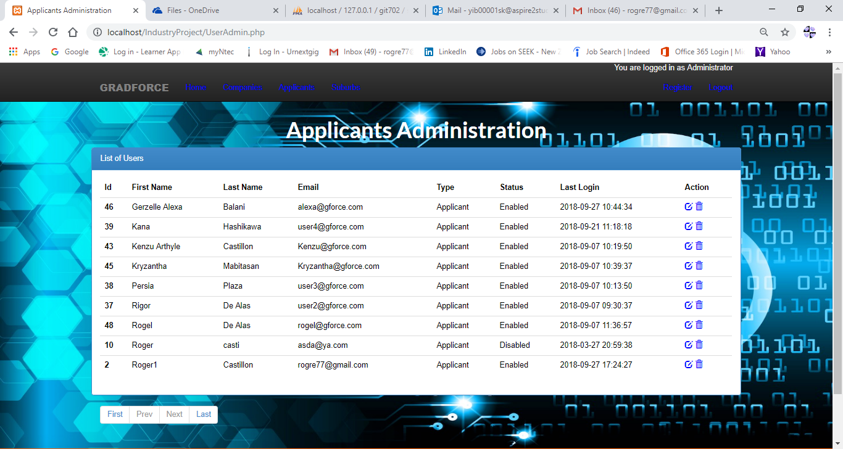

### Cities/Suburbs Administration Page

This screen is for the system administrator’s used only. The  button opens the **Update City/Suburb** page that allows to update the suburb and the  button deletes the record.

